Tasks

1. Docker Installation

Install Docker on your local system (Windows, macOS, or Linux).
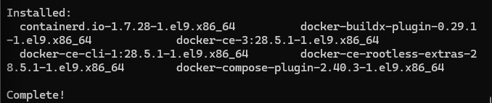
Verify installation by running:
docker --version
docker info
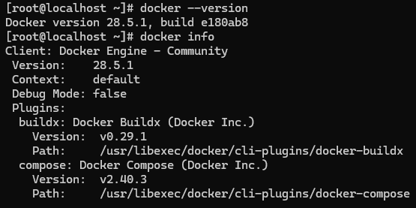

2. Working with Docker Images
Search for the official Ubuntu image on Docker Hub.
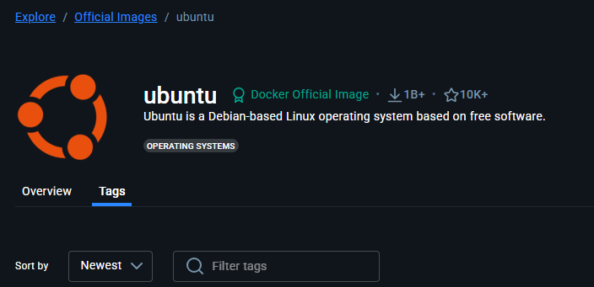
Pull it to your local system using docker pull.
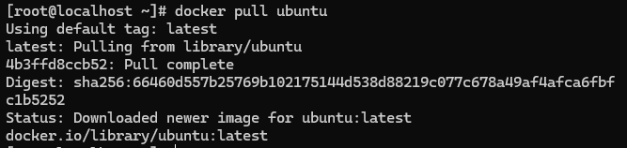
List all available images using:
docker images
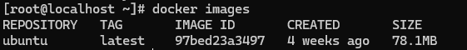

3. Creating a Docker Container
Run a container using the Ubuntu image.
Execute a command inside the container:
echo "Hello, Docker!"

4. Inspect Container (Created State)
Verify that the Ubuntu container is in the "created" state.
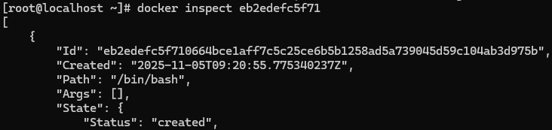
5. Run Container (Running State)
Execute the Ubuntu container and confirm it’s in the "running" state.
6. Launch and Remove HTTP Container
Launch an HTTP container.
Verify its state.
Remove both the container and its image from your system.
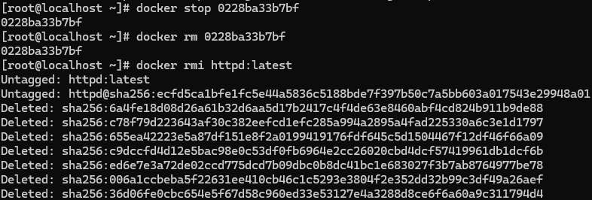

7. List Short Container IDs
Execute a command that displays only the short container IDs.
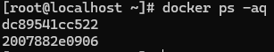

8. Clone & Build Custom Image
Clone the repository: lancachenet/ubuntu-nginx
Build a Docker image using the provided Dockerfile.
Add relevant tags while building the image.

9. Run & Test the Webpage
Run a Docker container using the newly built image.
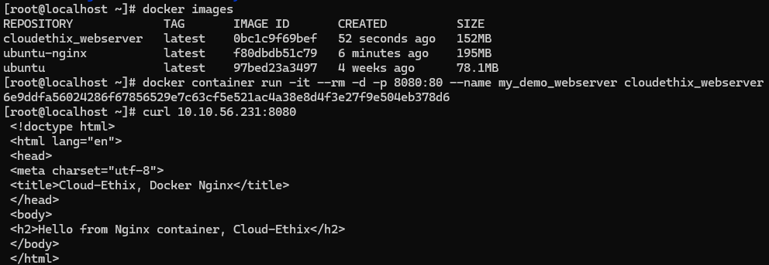
Use the curl command to verify that the webpage is accessible.

10. Container Detach & Reattach
Launch an Ubuntu container.
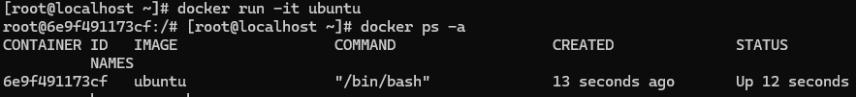
Demonstrate the escape sequence (detach).
While inside the container, press the escape sequence: Ctrl +p Ctrl +q
Reattach the container after detaching.
Check and note down the container’s IP address.
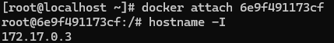

12. Inspect Host Configuration
Use a Docker command to inspect the hostname and the /etc/hosts file of the httpd container.
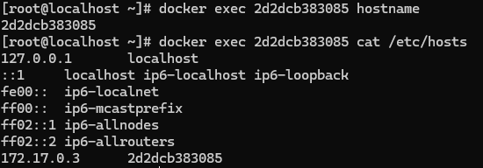
13. Monitor Container Stats
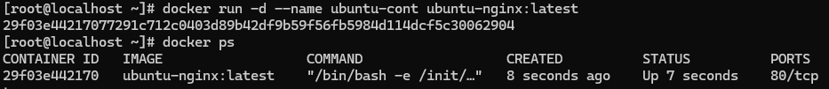
Inspect a container created with the lancachenet/ubuntu-nginx image.
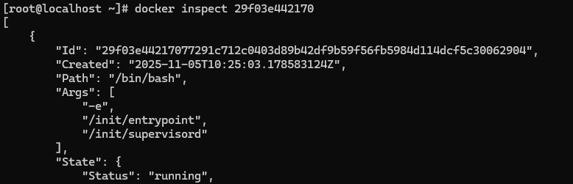
Monitor its resource usage and stats using the top command.
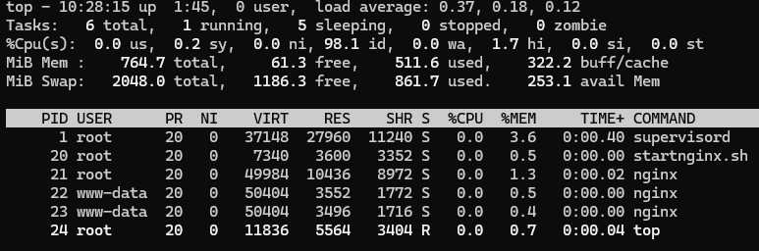
14. Nginx Containers Log Review
Start a new Nginx container.
Review and compare the logs for both Nginx containers.
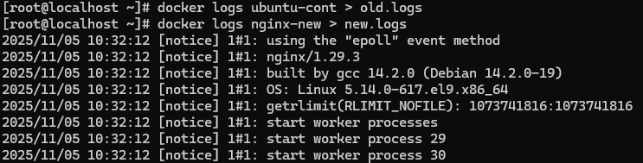
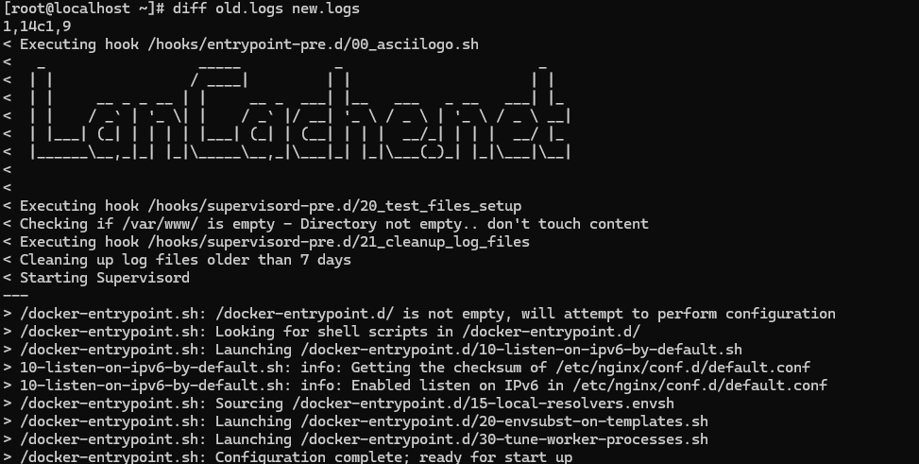
15. System Events & Filters
Examine Docker system events filtered by:
Specific date, and
The last 30 minutes.
Apply two filters simultaneously using name and event.

16. Custom Hostname & Logs
Create an Ubuntu container with: A meaningful name, and Hostname set to cloudethix.com.
Stop or kill the container.
Check its exit code and review its logs for details.
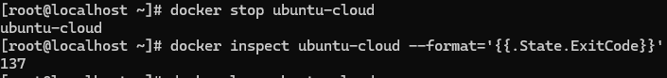

17. Container Management Operations
Create and start an Ubuntu container with a random name, then rename it to Ubuntu01.
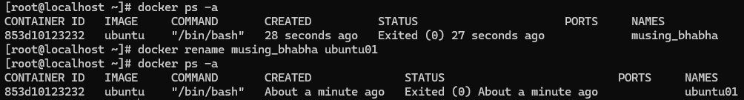
Launch another container named Ubuntu02.
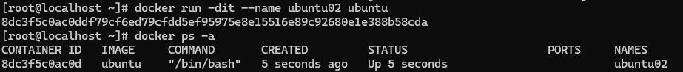
Check the hostname for both containers.
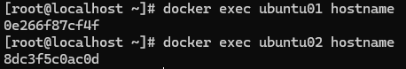
Perform the following:
Pause and unpause Ubuntu02.
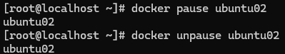
Stop, start, and restart Ubuntu01.
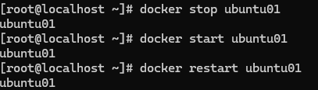
Inspect stats and system events for both.
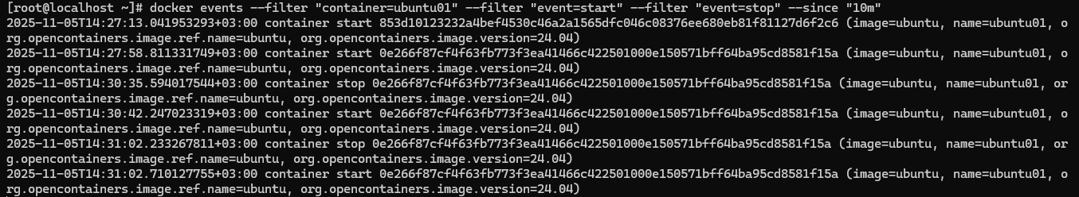
Finally, kill and delete the containers, ensuring all created directories are removed.
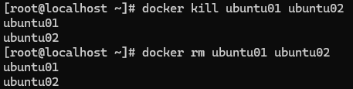

18. DockerHub Repository Setup
Create a DockerHub account.
Set up a repository with a meaningful name.
